**TELANGANA AGRICULTURE QLIK REPORT**

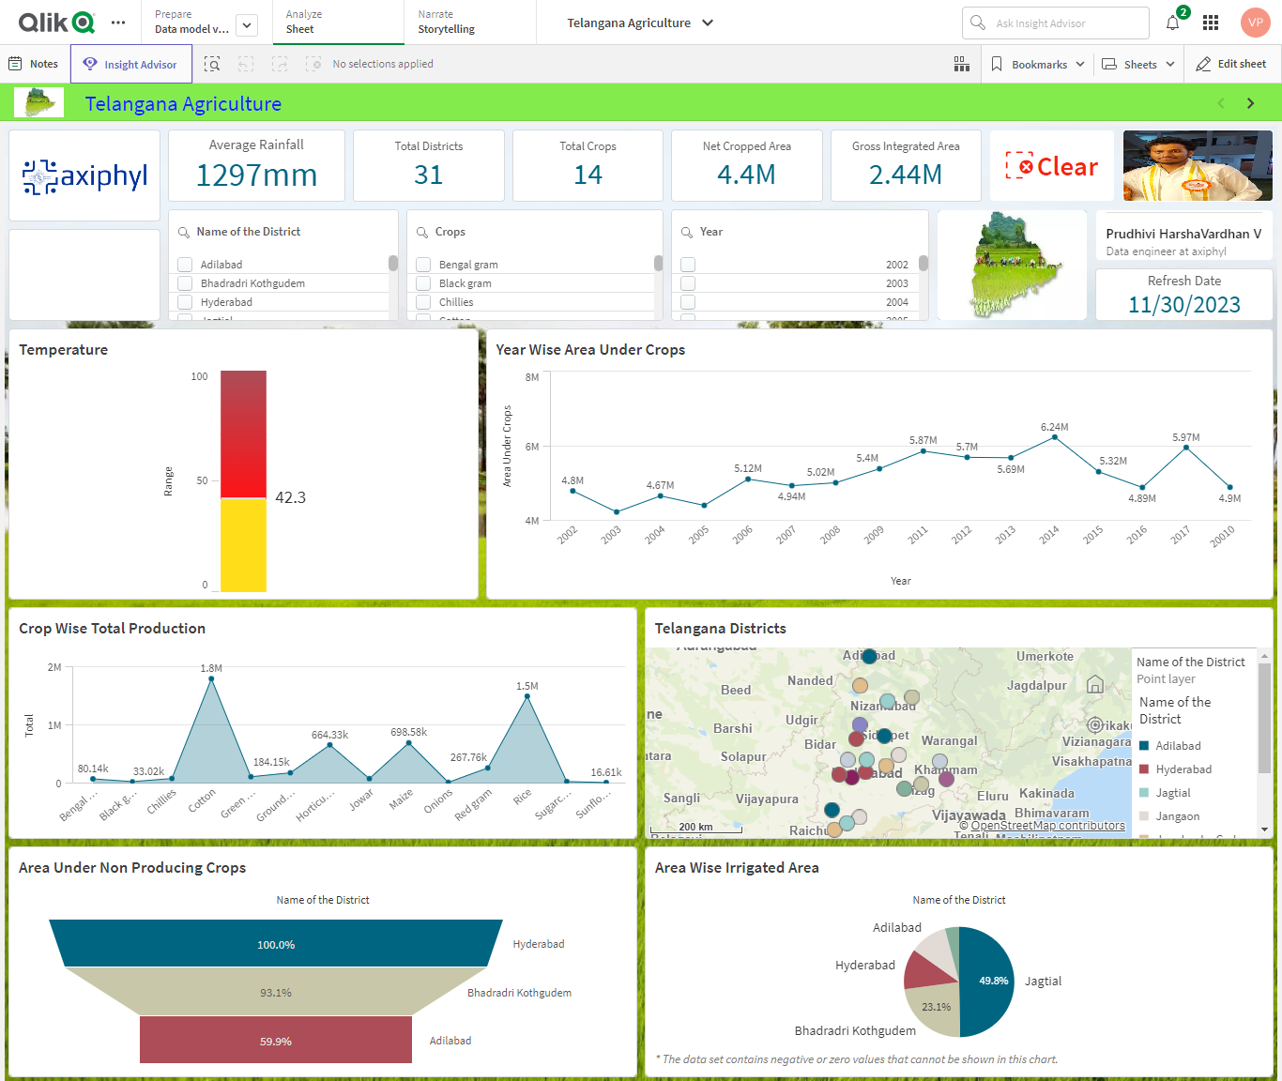

The main objective of this report is to analyse how Telangana, a state in southern India, has a predominantly agrarian economy, with agriculture playing a vital role in its socio-economic landscape. At what temperature and rainfall do we get more yield, and how many Rythu bazars and market communities do we have and which crops yield more. An understanding of the Telangana Agriculture process and data is required to read the report.

**Project Overview**

Data Source

Problem Statement

Key Performance Indicators (KPIs) and Data Dictionary

Executive Summary and Problems Encountered

Key Insights -Positive

Key Insights -Negative

Suggestions

Data Source

My Qlik Report consists of the following steps:

**Data collection:** Dataset has been collected from Telangana Official Website.

**Data Preparation:** The dataset has been cleaned and processed for the analysis.

**Exploratory Data Analysis:** Data has been analysed to understand which crops yield more at certain temperatures and rainfalls based on year.

**Data visualization:** we’ll Visualize the data to identify the Telangana Agriculture.

**Simple Recommendation System:** Developed a visualization of sales in Telangana Agriculture.

 Key Performance Indicators (KPIs) and Data Dictionary

Key Performance Indicators

**Average Rainfall(mm):** Avg (Annual Rainfall(mm))

**Total Districts:** count (Total Districts)

**Total Crops:** count (total Crops)

**Net Cropped Area:** sum (Net Cropped Area)

**Gross Integrated Area:** sum (Gross Integrated Area)

**Data Dictionary**

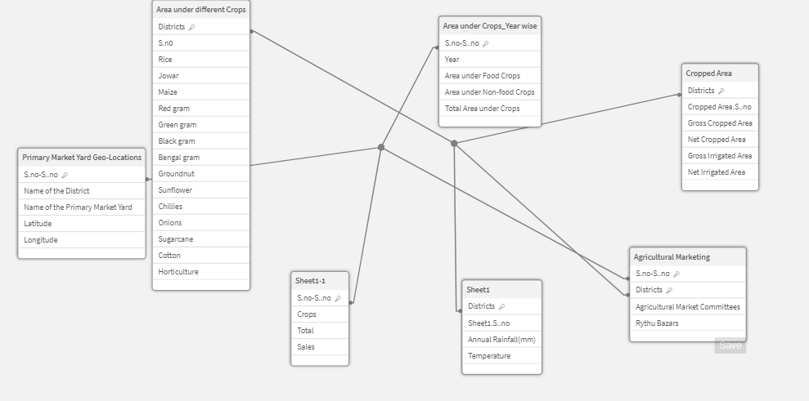

Executive Summary and Problems Encountered

The dataset contains several columns representing various attributes of Telangana agriculture, including the name of the district, year, temperature, rainfall, irrigated area, non-irrigated area, total yield of crops like cotton, chilies, black gram and the same fields. Examining Yield and seeing any patterns or Production on yield of agriculture might be part of this goal.

**Problems Encountered**

1.Choosing the correct data set was a challenge.

2.Selecting the proper KPI for the project was the other challenge. I have googled and gone through previous projects to come up with the right KPIs for the project.

3.Selecting the right KPI was the other problem occurred. MoM% was initially attempted but it does not show the desired output so there was a need to change it to YoY%.

Positive Insights:

|  |  |
| --- | --- |
| Insight | Positive |
| KPI | Average Rainfall |
| Good or Bad | Good |
| Responsible Dim | Genre/Year |
| More Effect Occurred | The Sales Year over Year Increased |
| Where It is Occurred | Telangana in INDIA |
| When the problem occurred | 2002 to 2017 |

Key Insights – Negatives

|  |  |
| --- | --- |
| Insight | Negative |
| KPI | Average Rainfall |
| Good or Bad | Bad |
| Responsible Dim | Genre/Year |
| Where It is Occurred | Telangana in INDIA |
| When the problem occurred | 2002 to 2017 |

Suggestions

Improving agriculture involves addressing various aspects, from increasing productivity and sustainability to enhancing the livelihoods of farmers. Here are some suggestions to improve agriculture:

1. Adoption of Technology:

Integrate modern agricultural technologies such as precision farming, drones, and sensors to optimize resource use, monitor crop health, and improve overall efficiency.

1. Access to Information:

Provide farmers with easy access to information about weather patterns, market prices, and best agricultural practices. This can empower them to make informed decisions.

1. Irrigation Management:

Implement efficient irrigation systems and water management practices to address water scarcity issues and ensure optimal water use in agriculture.

1. Crop Diversification:

Encourage farmers to diversify crops to improve resilience against pests, diseases, and market fluctuations. Diversification can also enhance soil health and reduce the risk of crop failure.

1. Improved Seeds and Varieties:

Promote the use of high-yielding and climate-resilient crop varieties. This can lead to increased productivity and better adaptation to changing environmental conditions.